**Task 3- ChatGPT**

**CSS Selectors and How They Work**

**CSS selectors** are used to "select" HTML elements that you want to style. They allow you to apply styles to specific elements based on their tag name, class, ID, attributes, or other criteria.

**Common CSS Selectors:**

1. **Element Selector**:
   * Targets all instances of a specific HTML element (e.g., all <p> tags).
   * Example: **p { color: red; }**
2. **Class Selector**:
   * Targets elements with a specific class attribute (e.g., all elements with **class="highlight**").
   * Example**: .highlight { background-color: yellow; }**
3. **ID Selector**:
   * Targets a single element with a specific ID (e.g., **id="main-title**").
   * Example: **#main-title { font-size: 24px; }**
4. **Attribute Selector**:
   * Targets elements based on the presence or value of a specific attribute (e.g., **<input type="text**">).
   * Example: **input[type="text"] { border: 1px solid black; }**
5. **Pseudo-class Selector**:
   * Targets elements in a specific state (e.g., **:hover** for when the user hovers over an element).
   * Example: **a:hover { color: green; }**

**Example HTML Document with CSS Selectors**

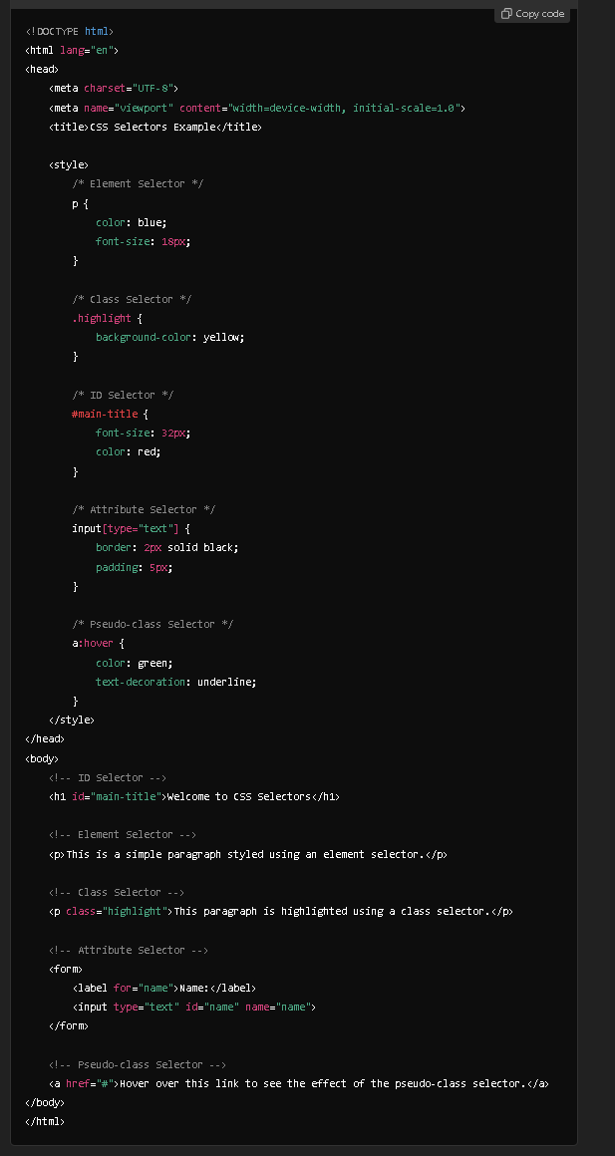

**Explanation of CSS Selectors in the Example:**

1. **Element Selector (p)**:
   * Targets all <p> tags and styles them with blue text and a font size of 18px.
2. **Class Selector (.highlight)**:
   * Targets any element with the class highlight, giving it a yellow background.
3. **ID Selector (#main-title)**:
   * Targets the element with the ID main-title and makes the font size larger (32px) and red in color. IDs should be unique to each page.
4. **Attribute Selector (input[type="text"])**:
   * Targets <input> elements where the type attribute is equal to "text". It adds a black border and padding around the text input.
5. **Pseudo-class Selector (a:hover)**:
   * Changes the color of <a> links to green and adds an underline when the user hovers over them.

**Summary:**

* **Element Selector**: Targets all instances of a specific HTML tag.
* **Class Selector**: Targets elements with a specific class.
* **ID Selector**: Targets a unique element with a specific ID.
* **Attribute Selector**: Targets elements based on specific attributes.
* **Pseudo-class Selector**: Styles elements in a particular state, like when they are hovered over.

These selectors help control which elements are styled, making CSS powerful and flexible in defining the presentation of a web page.

**Result :**

**Before Hover:**

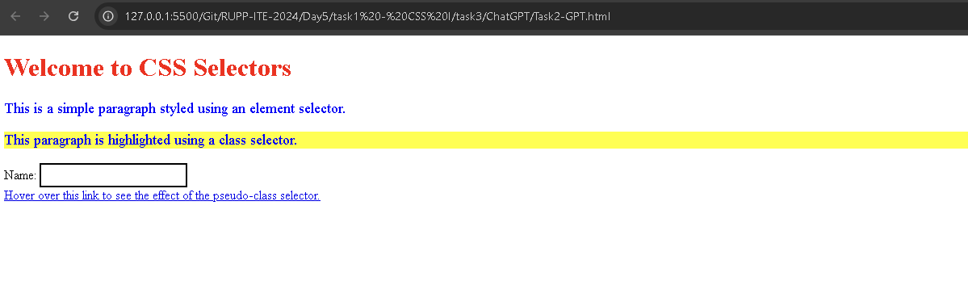

**Hover:**

